TITLE | Door Lock simulation Using Beagle Bone black and LED with authentication.
PROBLEM STATEMENT / DEFINITION | Using Python/Java with BBB development board write a embedded security application of a password based door lock(stepper motor can be used with Photo diode or use LEDs. Use Mobile/ laptop/ desktop as a hotspot device/ Bluetooth device to lock or unlock the door.
OBJECTIVE | - To understand the design of Beagle Bone Black  - How to make use of GPIOs
S/W PACKAGES AND  HARDWARE APPARATUS USED | - Beagle Bone Black  - LEDs  - Mobile/ laptop/desktop
STEPS | 1) Connect BBB board to Machine using USB cable.  2) Install Python library to perform I/O programming on GPIOs  3) Switch can be interfaced to select the various LEDs '  - import Adafruit_BBIO.GPIO as GPIO  - import time  - GPIO.setup("P8_10", GPIO.OUT)  - while True:  - GPIO.output("P8_10", GPIO.HIGH)  - time.sleep(0.5)  - GPIO.output("P8_10", GPIO.LOW)  - time.sleep(0.5)  STEPS FOLLOWED FOR SIMULATION OF BEAGLE BONE BLACK:  1) Plug in your Beagle via USB  2) Install Driver  3) Browse to your Beagle
INSTRUCTIONS FOR  WRITING JOURNAL | - Title  - Problem Definition  - Objectives: Intention behind study  - Software & Hardware requirements  - Explanation of the assignment (Theory)  - Mathematical Modeling / UML diagram  - Algorithm /Steps performed  - Conclusion

Assignment No. B6.ES-C1

- Problem Statement
Using Python/Java with BBB development board write a embedded security application of a password based door lock(stepper motor can be used with Photo diode or use LEDs. Use Mobile/ laptop/ desktop as a hotspot device/ Bluetooth device to lock or unlock the door.

- Pre Requisite
- Knowledge of Programming in Python/Java
- Knowledge of Architecture of BBB

- Learning Objectives
- To understand the design of Beagle Bone Black
- How to make use of GPIOs

- Learning Outcomes:
Students will be able to develop small application using BBB and LED

- Explaination
Beagle Bone black is an open hardware, community-supported embedded computer for developers. It works with 1GHz with the Sitara™ ARM® Cortex-A8 processor. The REV C comes with Debian Linux pre installed. It has GPIO(69 max), which can be programmed using Python.
LEDs are the light emitting Diodes. LEDs have two wires. One wire is the anode (positive) and another is the catho de (negative). Push the LED leads into the breadboard, with the longer (positive) lead towards the top of the breadboard. It does not matter which way around the resistor goes. The top two connections on the BBB expansion header we are using (P8) are both GND. The other lead is connected to pin 10, which is the right-hand connector on the fifth row down.
Main concept behind this application is of a door-latch opening using a password entered through keypad. As well as turning on the Buzzer when password is entered wrong for multiple times. User can change this password anytime he/she wish using a keypad
The Components of this system are as follows:
1.BeagleBone Black
2.LED
3. Buzzer: We are going to use a buzzer to indicate the wrong password to open the door.
4. Keypad: User will enter the password using the keypad. Various keys of keypad are as following
I. 0 to 9 II. Enter III. Escape

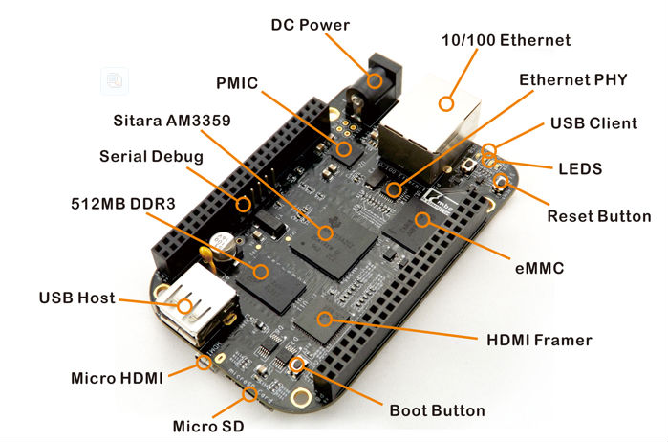

- Algorithm
Connect BBB board to Machine using USB cable.
Install Python library to perform I/O programming on GPIOs
Switch can be interfaced to select the various LEDs '
- import Adafruit_BBIO.GPIO as GPIO
- import time
- GPIO.setup("P8_10", GPIO.OUT)
- while True:
- GPIO.output("P8_10", GPIO.HIGH)
- time.sleep(0.5)
- GPIO.output("P8_10", GPIO.LOW)
- time.sleep(0.5)

INTERFACING OF BBB WITH COMPUTER:

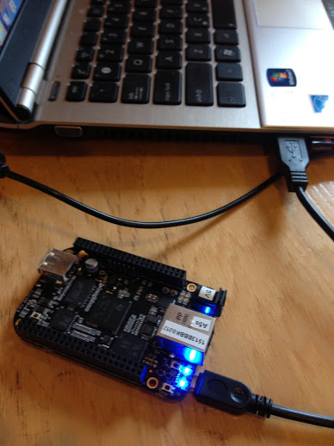

STEPS FOLLOWED FOR SIMULATION OF BEAGLE BONE BLACK:
1) Plug in your Beagle via USB
2) Install Driver
3) Browse to your Beagle

- Mathematical Modelling :
S={ I, O, Fn,S,F}
I=inputs={Password , door_status , no_of_attempts}
door_status={opened, closed}
O= outputs={door_opened,door_closed}
Fn={F_{open_door}, F_{close_door}}
F_{open_door}→door_status =open
F_{close_door}→door_status =open
If door_status=closed &no_of_attempts<3 ->F_{open_door}
If door_status=opened &no_of_attempts<3 ->F_{close_door}
S={ door_status_changed} Ifno_of_attempts<3
F={door_status_unchanged} Even If no_of_attempts<3

- Review Questions
What are the various components present on BBB REV C?
What are the functions of components which are present on BBB?
What is GPIO?

- Conclusion:
Thus, after successfully completing this assignment, you will be able to understand & implement Door Lock simulation Using Beagle Bone black and LED with authentication.

